MODUAL-2 (CSS & CSS 3)

1).What are the benefits of using CSS?

ANS. CSS handles the look and feel part of a web page.

Using CSS , you can control the color of the text , the

Style of fonts , the spacing between paragraphs , how

Columns are sized and laid out ,etc. CSS saves time- You

Can write CSS once and then reuse the same sheet in multiple

HTML pages.

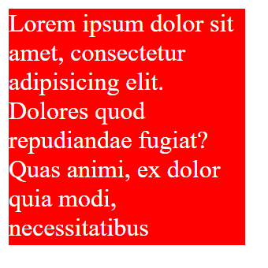

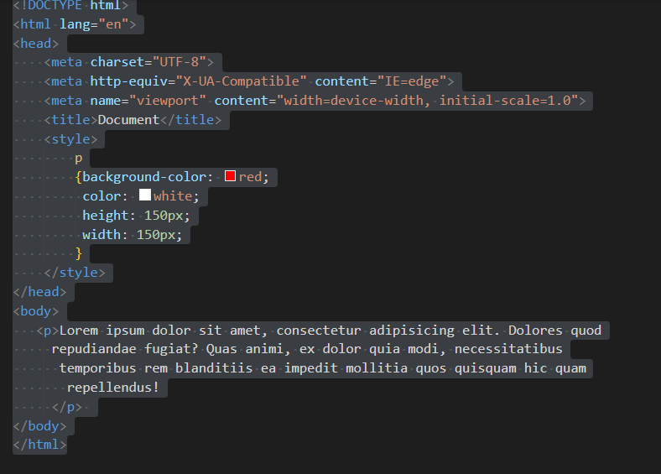

2). What are the disadvantages of CSS?

ANS. CSS, CSS1 up to CSS3 , result in creating of confusion

Among web browsres.

With CSS , what works with one browser might not always

Work with another. ….

There exists a scarcity of security.

After making the changes we need to confirm the compatibility

If they appear.

3). What is the difference between CSS2 and CSS3?

ANS. Unlike CSS2, which was comprised of a single document,

CSS3 has its specifications divided into many individual modules ,

Which makes CSS3 a Whole lot easier to handle.

4). Name a few CSS style components?

ANS. The components of CSS style are:-

Selecter: HTML element name , id name , class name .

Property: It’s like an attribute such as background color ,

font-size, position , text-align, color , border etc.

Values: which defines property or values allocate for properties.

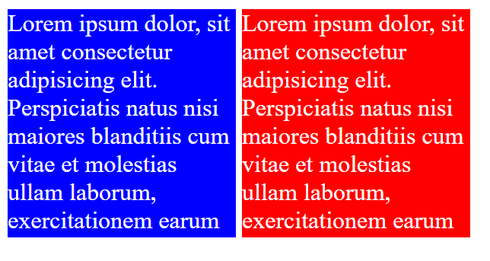

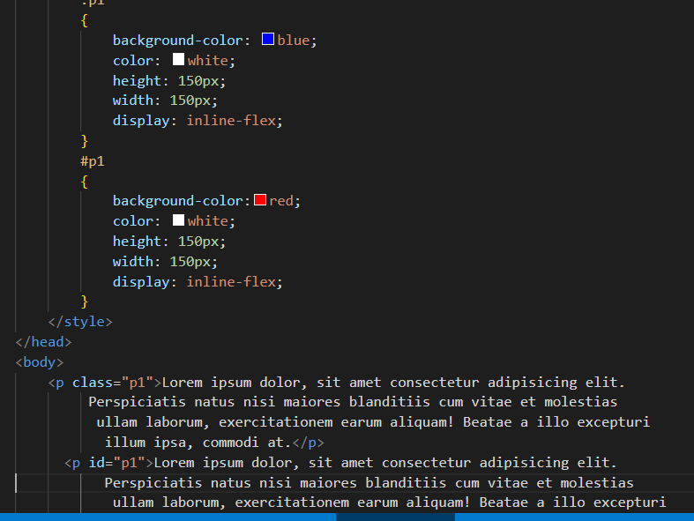

5). What do you understand by CSS opacity?

ANS. The opacity CSS property sets the opacityof an element. Opacity is the degree to which content behind an element is

Hidden , and is the opposite of transparency.

6). How can the background color of an element be changed?

ANS. How to change a div background color:-

* Add a CSS class to the div you’ d like to change . First , find the div in your HTML code and add a class to the opening tag. …
* Add the new class selector to your CSS code . Next , head over to your CSS code and add your new class selector. ….
* Choose a new background color.

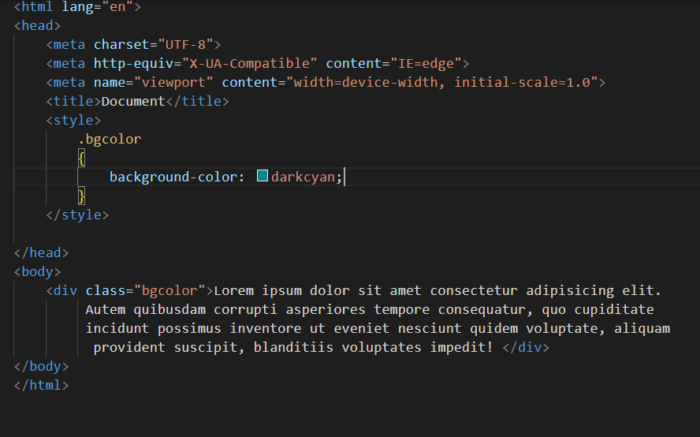

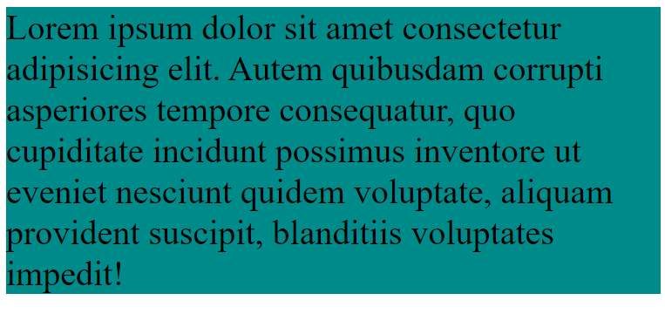

7). How can images repetition of the backup be controlled?

ANS. To control the repetition of an image in the background , use the background – repeat property. You can use no-repeat value for the background –repeat prpperty if you do not want to repeat an image, in this case, the image will display only once .

8).What is the use of the background –position property ?

ANS. The background –position property sets the starting position

Of a background image.

* Tip:- By default, a background –image is placed at the top

-left corner of an element , and repeated both vertically and

Horizontally.

9). Which property controls the image scroll in the background ?

ANS. The background –attachment property sets whether a background image scrolls with the rest of the page, or is fixed.

10). Why should background and color be used as separate properties?

Ans. There are two reasons behind this: it enhances the legibility of style sheets.

The background property is a complex property in CSS , and if it is combined with color, the complexity will further increase.

11).How to center block elements using CSS1?

ANS. With CSS the way to center anything that’s a block level element is with the margin property . One of the values of margin is auto and by settting auto on the left and right margin our block level element will center itself.

13).What are the ways to intergrate CSS as a web page?

ANS.CSS can be added to HTML documents in 3 ways:

* Inline: by using the style attribute inside HTML elements.
* Internal- by using a <style> elements in the <head> section.
* External- by using a <link> element to link to an external CSS file.

14).What is the embedded style sheet ?

Ans. Embedded style sheet- it allows you to define style for a particular HTML document as a whole in one place . This is done by embedding the <style></style> tags containing the CSS properties in the head of your document.

15).What are the external style sheets?

ANS. An external style sheet is a separate CSS file that can be accessed by creating a link within the head section of a the webpage. Multiple web pages can use the same link to access the style sheet.

The link to an external style sheet is placed within the head section of the page .

16). What are the advanteges and disadvanteges of using external style sheets?

ANS. External style sheets have the following advanteges over internal and inline styles:-

* One change to the style sheet will change all linked pages.
* You can create classes of styles that can then be used on many different HTML elements.
* Consistent look and feel across multiple web pages.

17). What is the meaning of the CSS selector?

ANS. A CSS selector is the first part of a CSS Rule . It is a pattern

Of elements and other terms that tell the browser which HTML elements should be selected to have the CSS property values inside the rule applied to them .

18). What are the media types allowed by CSS ?

ANS. Continuous or paged .

* Visual, audio , speech , or tactile .
* Grid(for character grid devices ), or bitmap.
* Interactive (for devise that allow user interaction ). Or static (for those that do not ).
* All (includes all media types ).

19).What is the rule set?

ANS.A collection of rules or signatures that network traffic or system activity is compared against to determine an action to take –such as forwarding or rejecting a packet, creating an alert , or allowing a system event.